**Unit Types**

If you intend on adding additional types to the game, unit types can be defined through the **UnitType** class. However, it is recommended to use the predefined set of units of the game (defined in the **UnitTypeTable** class), which are:

**Predefined Units in the Game**

**Category: Building Type Units- Visually Square on the Playing Grid**

* **Resource**: the elements in resource units do not belong to any single player. Resource Units cannot execute any actions. It only has one property: resources left. When the number of resources left reaches 0, the unit is finalized and disappears.
* **Base**: Base units have 10 hit points; it can be attacked and hit by an attacking unit 10 times before it is destroyed. You will have to use 10 resource units to build a base. You will have to wait until 250 time units elapse before the base unit is built. They can only execute one action, produce. And they can only produce Workers.
* **Barracks**: Barracks are more vulnerable than base units; they have only 4 hit points. They can only withstand being hit 4 times before they are destroyed. They cost 5 resource units to build, and take 200 time units to be built. They can only execute one action, produce. And they can produce three variety of attack units;

1. Light units,
2. Heavy units
3. Ranged units.

**Category: Military Units / Movable Units**

Worker Unit Description

* **Worker**: The worker unit is the basic fundamental type of unit that you start the game with. They have only 1 hit point and they cost 1 resource to build. It only takes 50 time units to be built a worker. Workers can carry one resource. It takes them 10 units of time to advance from one square to another adjacent square, which is (10 units of time per move), They consume 5 units of time to attack, that is (5 units of time per attack.

They can only cause 1 unit of damage per attack).

A worker can only attack an adjacent cell on the grid

They can harvest (20 units of time), and return (10 units of time). ???

Workers can only attack, harvest or return to units that are in the cell immediately up, left, right or down, adjacent.

Military Attack Unit Descriptions

* 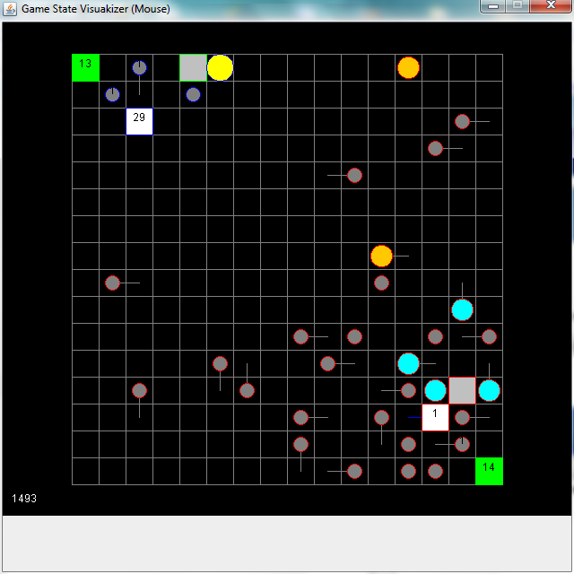**Light Attack Unit**: Light attack units have 4 hit points when created; they can withstand four attacks before they are destroyed. They cost 2 resources to build, and take 80 time units to be built. Light units can move (8 units of time per move). They use 5 units of time per attack, similar to a worker unit, attack (5 units of time per attack. The light attack unit causes 2 hit points of damage when they attack. That is twice the fire power of the worker unit

Illustration of a Light Attack Unit

* **Heavy Attack Unit**: Heavy units have 4 hit points when created; they can withstand four attacks before they are destroyed. They cost 2 resources to build, and take 120 time units to be built. Heavy units can move (12 units of time per move) and attack (5 units of time per attack) Heavy units can cause 4 hit points of damage when they attack. Four times the attack power of the worker and twice the fire power of the light attack unit.

Illustration of a Light Attack Unit

* **Ranged Attack Unit**: have 1 hit point, they can be easily damaged. they cost 2 resource units to build, and take 100 time units to be built. Ranged units can move (12 units of time per move). They take 5 units of time to attack location 5 units of time per attack. They can cause 1 unit of hit point of damage to the unit they are attacking. The significant advantage of this unit is that it can attack at distances of 3 or less squares.

Illustration of a Light Attack Unit

**The square units correspond to:**

* “**Bases**”, the bases can produce additional workers
* “**Barracks**”, barracks can produce military units and resource mines. Additionally, barracks are resource from where workers can extract resources to produce more units), The circular units correspond to workers and military units

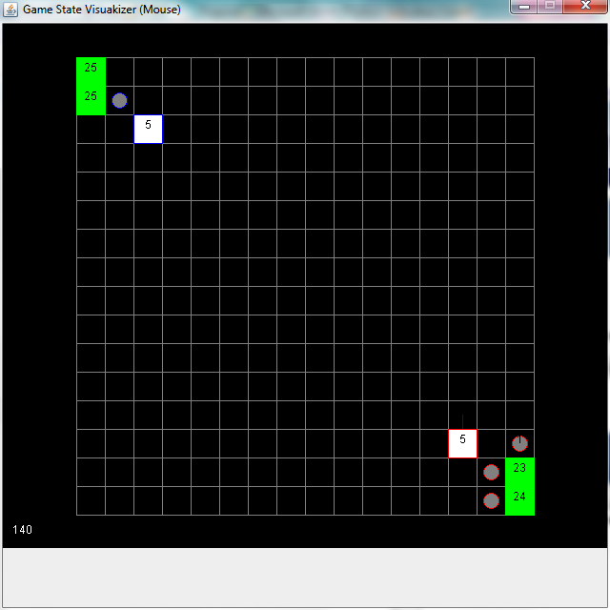 This diagram displays a base on the game grid. The base while in existence, will always contain an integer value on it. The integer value displays the number of material/resource units that have been deposited into the base. A player sends worker units to resource buildings, to retrieve resource units and deposit them into bases. A player gets a base with five resource units at the start of a game. A base is used to create additional workers and to feed the production of military attack units.

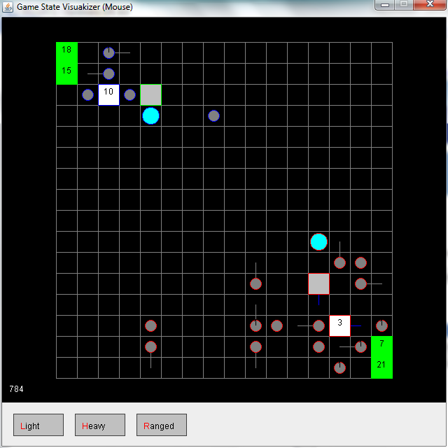**Resource Building Base Barrack**

This diagram displays five different units on the playing grid for a player. The green square represents two resource buildings. The two workers with the lines protruding from them are moving resource units from the resource building to the white square representing the base. The grey square is a barrack; the worker unit next to it was used to construct it. Finally the blue circle is an attack unit. It was created by the barrack. It emerged from one of the sides of the Barrack.

**Worker Military Attack Unit**

**Gathering Resources**

**Visually the units can be divided into two categories; squares and circles.**

**The square units are:**

* Bases - white/grey squares are buildings
* Barracks- white/grey squares are buildings
* Resources - The green boxes on the game grid are resources

**The Round Units are the workers and the military units:**

A worker can perform a variety of actions:

1. Move Up
2. Move Down
3. Move Left
4. Move Right
5. Stand Still
6. Harvest Resource
7. Build a Barrack
8. Build a Mine

What is the definition of a time unit?

**How to Navigate the Game**

**To Select a Unit**: left click on the unit

**To Move a Unit**: first left click it to select, then right click on the cell in the grid that you want it to move to.

**To Attack a Unit:** First select the attacking unit, and then right click on the unit to attack. Remember, only the range unit can attack further than one adjacent square. The range unit has a distance of three squares

**Harvest Resources/Minerals:** First select the unit to receive the recourse, and then right click on the building containing the resource.

This permits you to move resources to create additional workers, one worker per resource.

**Construct Buildings**: First, select the type of building at the bottom of the game grid, and then right click on the destination square in the grid where you want to place the constructed building. Remember there is a time and resource penalty/cost for constructing a building.

When constructing a building you must first make sure that your workers have accumulated enough resources to build the artifact. Then you must select an available worker for the construction. Once you have selected the worker to perform the construction, two command buttons will appear at the bottom of the screen, (barrack or base). Left click the type of building that you want the worker to construct. Finally, right click on the square in the grid that you want to construct the building on. This will move a worker to position that is next the selected destination for the building. The worker will be pointing to the destination. After the appropriate build time passes, the building will appear on the destination square.

**To Create Attack Units**: Attack units are light, heavy and range types. You must first construct a building before you can create attack units. Each specific type of attack unit has strength and weaknesses. There is a cost in ((time units) and resources) to build an attack unit. See: **Attack Unit Description** for specific costs of building each type of attack unit.

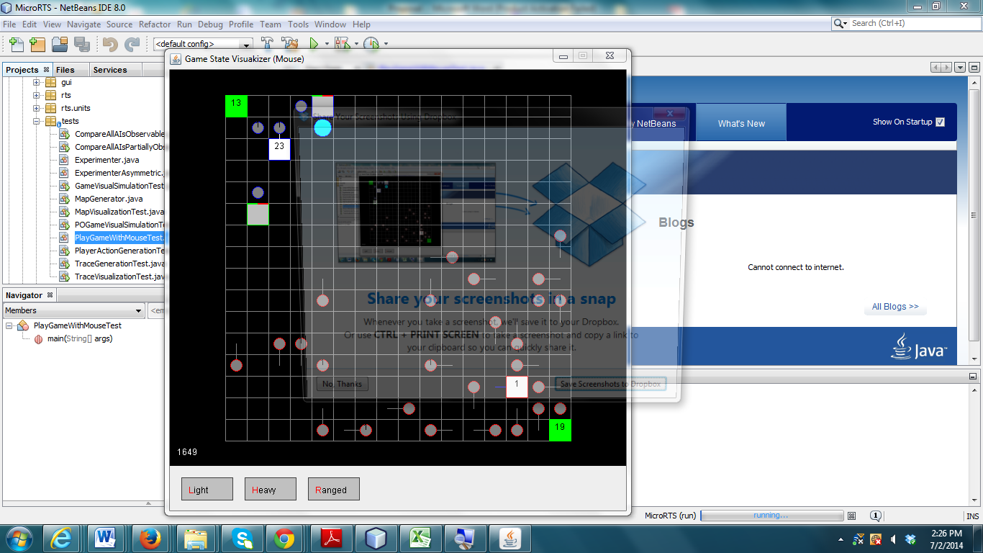Select the building to that you want to use to create the attack unit. Three command buttons will appear at the bottom of the game grid when you have a building selected, Light, Heavy and Range as illustrated in the diagram

Select the attack unit that you want the building to create. The attack unit will appear after the time units to create the attack unit has elapsed

**Train: Still need to find this out**

 In this screen shot there are three different types of units. The green squares represent two different resource units at two separate locations on the playing grid. The white square represents a base unit. The grey circular unit represents a worker unit. Once give the command, the worker unit will start transferring resources, 1 resource at a time, from the resource building to the base building. The resources must be transferred from the resource building to the base building in order to utilize the resource. Resources are not owned by any one player. Any player on the playing area can utilize a resource. When a base contains resources, it can start producing workers. Workers are required to build (bases and barracks). Once a barracks is constructed, a player may begin to create any one of the three types of attack units. A player may have any number of attack units, barracks, bases or workers in the playing area.

**Creating Additional Workers-**  bases can produce additional workers. When a base contains resources, it can start producing workers.

When a Base is selcted, a command button is displayed at the bottum of the playing grid, The command button has the lable **Worker** on it. As it is displyed on the diagram. Left click the worker Button at the bottum of the playing grid. The Base will point to and cell adjacent to it. After the time cost for a worker unit has elapsed, the worker unit will appear at the square that the base is pointing to. The base resource count will decrease by one to cover the material cost for creating the worker unit.

**Appendix**

